

Installation Guide

M2M IITC – Azure Jenkins Plugin

CM+

**Author:** CELFOCUS

**Last Update:** 2017-09-04

**Version:** 1.0

Copyright © CELFOCUS. All RIGHTS RESERVED TO CELFOCUS and its Licensors under Law. The disclosure, copying, adaptation, citation, transcription, translation, and/or any other form of total or partial use of the content, layout and graphic design, images or sound of this document or accessible herein, by any means of using any format (physical or virtual) without the respective authorization or licensing by CELFOCUS or its Licensors is prohibited and offenders shall be prosecuted. The user or licensee of all or part of this document may only use the document under the terms and conditions agreed upon with CELFOCUS and/or its Licensors for the purposes determined, otherwise subject to civil and/or criminal prosecution

of the offenders.

**CELFOCUS – Soluções Informáticas para Telecomunicações, S.A.**

Avenida D. João II, Lote 1.03.2.3

Parque das Nações

1998-031 Lisboa, Portugal

Tel. +351 213 836 300 . Fax +351 213 836 301

www.celfocus.com

Document Control

|  |  |
| --- | --- |
| Title | CM+ |
| Date | 04-09-2017 |
| Version | 1.0 |
| Reference |  |
| Associated Documents |  |
| Written by | CELFOCUS |
| Approved by | Celfocus |
| Addressed to | Vodafone |

Proprietary Notice

This document contains information specific and confidential to Vodafone. Reading this document is an undertaking to observe the confidentiality and copyright of the Vodafone information and to undertake that the information contained herein will not be reproduced in whole or part, discussed, or distributed under any circumstances without the prior written permission of Vodafone.

Product and company names are trademarks or registered trademarks of their respective holders.

Distribution List

|  |  |  |
| --- | --- | --- |
| Name | Role | Action Required  (None / Review / Approve / Sign-off) |
|  |  |  |
|  |  |  |
|  |  |  |
|  |  |  |

Revision History

|  |  |  |  |
| --- | --- | --- | --- |
| Version | Date | Description | Revised By |
| 1.0 | 04-09-2015 | First version |  |
| 1.0 |  |  |  |
| 1.1 |  |  |  |

Referenced Documents

Referenced using [Nr.] throughout the document

|  |  |  |  |
| --- | --- | --- | --- |
| Nr. | Document Title | Author | Description |
| 1 |  |  |  |
| 2 |  |  |  |

Table of Contents

1. Introduction 6

1.1. Document Purpose 6

1.2. Intended Audience 6

1.3. Scope 6

1.4. Out of Scope 6

1.5. Acronyms and Abbreviations 6

1.6. Assumptions 6

2. Installation Process 7

2.1. Jenkins Plugin 7

3. Prerequisites 8

3.1. 8

Table of Figures

No table of figures entries found.

Table of Tables

Table 1 – Acronyms and Abbreviations 7

# Introduction

## Document Purpose

The purpose of this document is to provide a complete guide for the installation and configuration of the Azure Jenkins Plugin.

## Intended Audience

This document should be used by those who aim to automate stop/start tasks over the virtual machines available on an Azure account, and some basic knowledge about Jenkins functionalities.

## Scope

This document scope covers installation and configuration in order to execute the automated tasks.

## Out of Scope

NA

## Acronyms and Abbreviations

The following Acronyms and Abbreviations are used throughout this document:

Table 1 – Acronyms and Abbreviations

|  |  |
| --- | --- |
| Acronym / Abbreviation | Description |
| WLS | WebLogic Server |
| STG | Staging |
| PRD | Production |
| M2M-IITC | Machine to Machine – Internet in the Car |
| EAI | Enterprise Application Integration |
| CRM | Customer Relationship Management |
| RCU | Repository Creation Utility |
| DB | Database |
| VM | Virtual Machine |
| SSH | Secure Shell |
| GET | Global Enterprise Technology |
| GO | Global Operations |
| MDS | Mobile & Data Services |

## Assumptions

N/A

# Installation Process

## Jenkins Plugin

Plugin is installed by importing an .hpi file. The installation process consists in:

1. Access to ‘Manage Jenkins’ > Manage Plugins

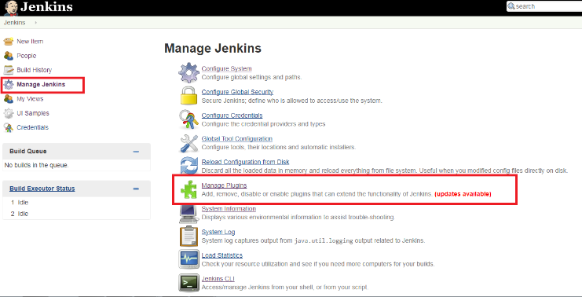

1. Select Advanced Tab

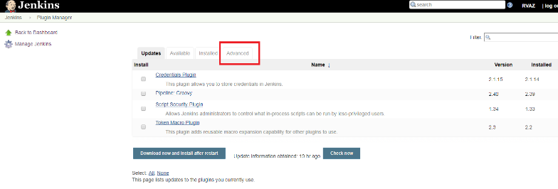

1. Import .hpi file.

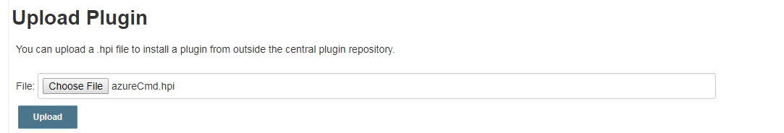

# Prerequisites

In order the application can access to virtual machines, a service principal must be registered in the target Azure account. The credentials to be used are the ones resulting from the registration process. If the application was already registred, you can skip these steps.

The following instructions are based on the official Microsoft Azure manual. For more details, use the [link](https://docs.microsoft.com/en-us/azure/azure-resource-manager/resource-group-create-service-principal-portal).

## Create an Azure Active Directory application

1. Log in to your Azure Account through the [Azure portal](https://portal.azure.com/).
2. Select **Azure Active Directory**.

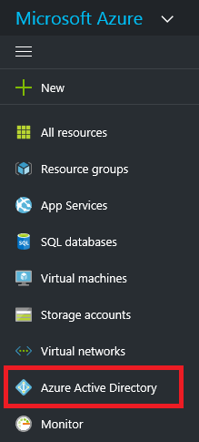

1. Select **App registrations**.

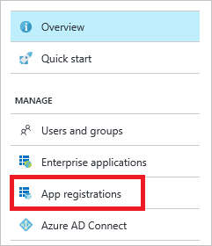

1. Select **Add**.



1. Set the following values:
   1. **Name:** CFazureCmd
   2. **Application Type:** Web app/ API
   3. **Sign-in URL:** http://CFazureCmd

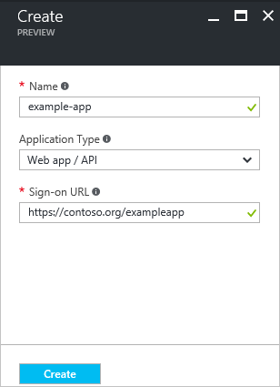

1. . After setting the values, select **Create**.

A notification will be raised confirming that the application was successfully registered.

## Get application ID and authentication key

1. From **App registrations** in Azure Active Directory, select your application.

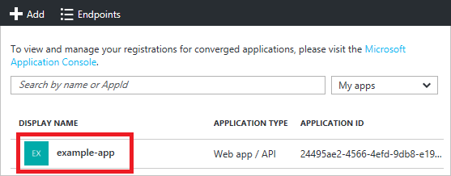

1. Copy the **Application ID** and store it. It will be used later.

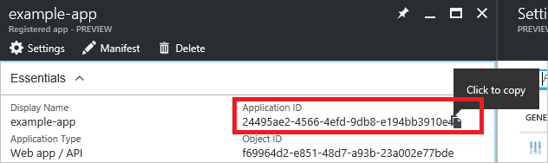

1. To generate an authentication key, select **Keys**.

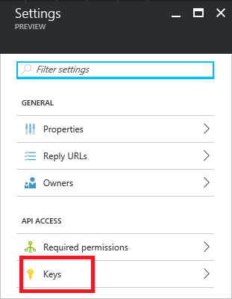

1. Provide a description of the key with the value **First Key**, and set the duration for the key to **Never**. When done, select **Save**.

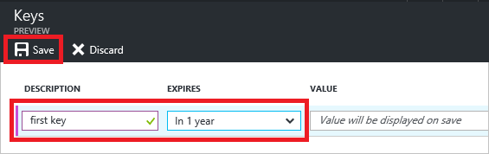

After saving the key, the value of the key is displayed. Copy this value because you are not able to retrieve the key later. You provide the key value with the application ID to log in as the application. Store this value, as it will be used for later configurations.

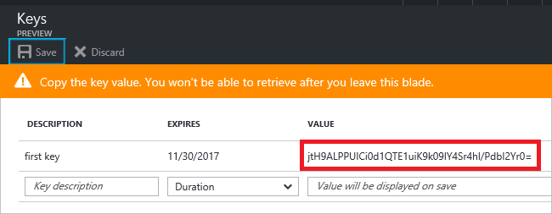

## Get tenant ID

1. To get the tenant ID, select **Properties** for your Azure AD tenant.

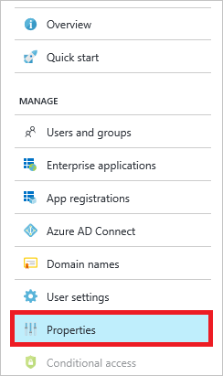

1. Copy the **Directory ID**. This value is your tenant ID.

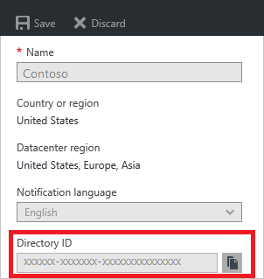

## Assign application to role

1. On the search box, type for **Subscriptions**.
2. Select the particular subscription to assign the application to.
3. Select **Access Control (IAM)**.

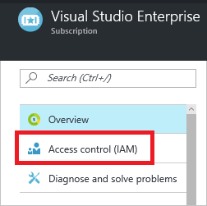

1. Select **Add**.

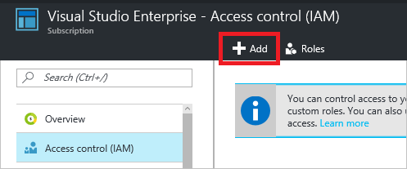

1. Select the role you wish to assign to the application. The following image shows the **Reader** role.

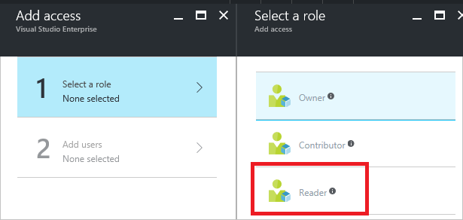

1. Search for your application, and select it.

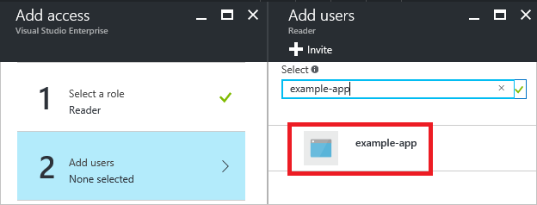

1. Select **OK** to finish assigning the role. You see your application in the list of users assigned to a role for that scope.

# Configurations

## Get VM Id

The operations to be executed are based on the Azure VM Id. The following steps describe how to get this Id.

1. In the Azure portal, select **Virtual Machines**.

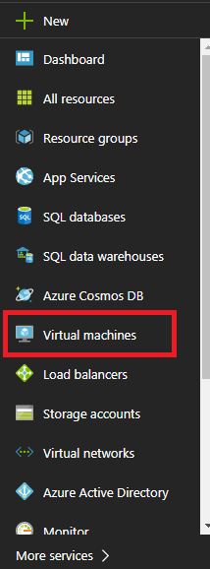

1. Select the VM record and drill in the name value.

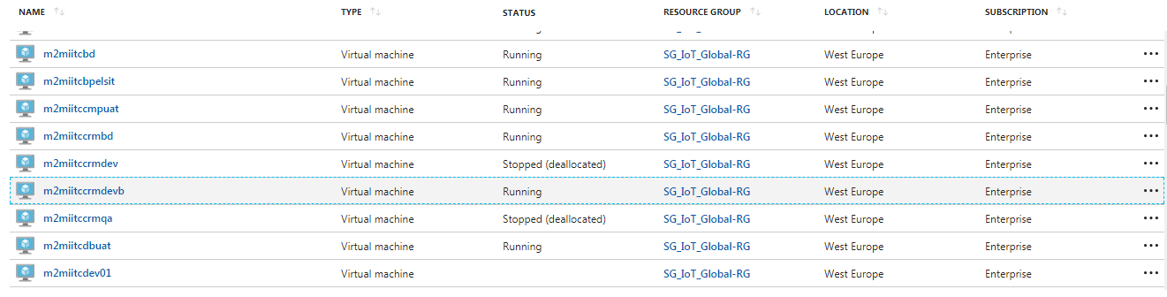

1. Select **Properties.**

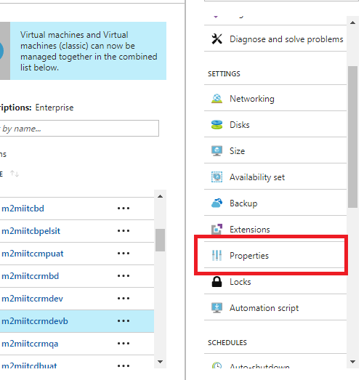

1. Copy **Resource Id** value by clicking te displayed button. Store this value as tihis will be later used to configure the plugin.

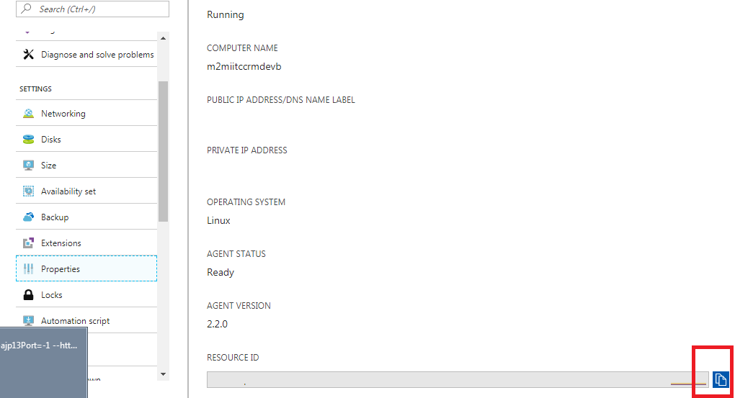

## Configure Jenkins Task

The plugin allows a job to execute the virtual machine’s operations. The following steps describe the how to configure the task in order to user the plugin.

1. Create a new task.

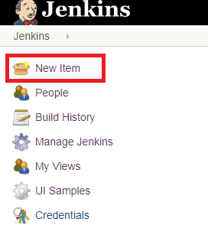

1. Specify a task name and select the Freestyle project.

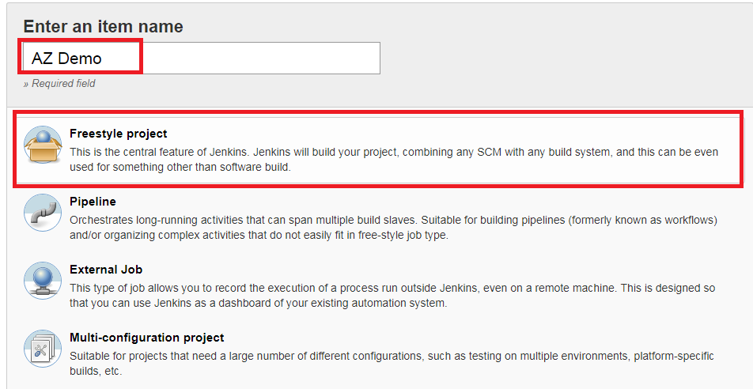

1. In the build section, add a step and select the Azure option.

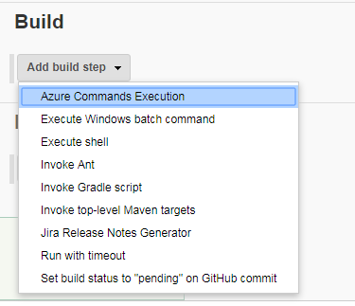

1. Define the input parameters accordin to the following description:

* App Id: copy the value from the **Application ID** in step 3.2;
* Tenant: copy the value from the step 3.3;
* Pwd: copy the value from the **Key** in step 3.2;
* VM Id: copy the value from step 4.1;
* Action: select the action to be executed over the specified VM.

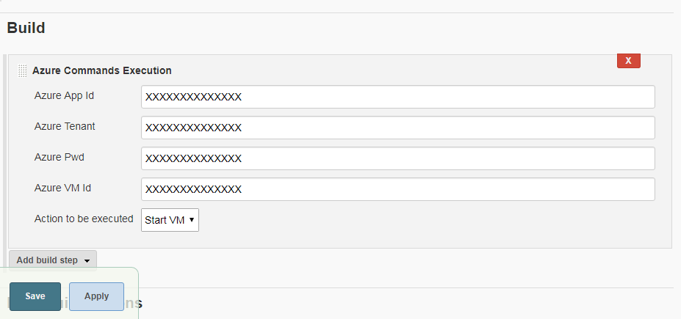

1. Save the changes. The task is now ready to run.

# Execution

## Execution Outputs

The plugin ill display some log regarding to successful operations or erros occurred. The log can be consulted by accessing the instance’s **Console Output**

Some examples are shown next:

**18:35:25** Started by user [RVAZ](http://localhost:9090/user/RVAZ)

**18:35:25** Building in workspace C:\Users\CF\.jenkins\jobs\AZ Demo\workspace

**18:35:25** ---------------------------------------------------

**18:35:25** Executing...

**18:35:25** ***********

**18:35:25** **Details**

**18:35:25** ***********

**18:35:25** - AppId: XXX

**18:35:25** |- Tenant: XXX

**18:35:25** |- Action: stop

**18:35:25** |- azVMId: XXXX

**18:35:55** VM: m2miitccrmdevb was stopped(deallocated).

**18:35:55** Finished: SUCCESS

**14:39:09** Started by user [RVAZ](http://localhost:9090/user/RVAZ)

**14:39:09** Building in workspace C:\Users\CF\.jenkins\jobs\AZ Demo\workspace

**14:39:09** ---------------------------------------------------

**14:39:09** Executing...

**14:39:09** ***********

**14:39:09** **Details**

**14:39:09** ***********

**14:39:09** - AppId: XXX

**14:39:09** |- Tenant: XXX

**14:39:09** |- Action: stop

**14:39:09** |- azVMId: TEST

**14:39:10** The specified ID `TEST` is not a valid Azure resource ID.

**14:39:10** Build step 'Azure Commands Execution' marked build as failure

**14:39:10** Finished: FAILURE